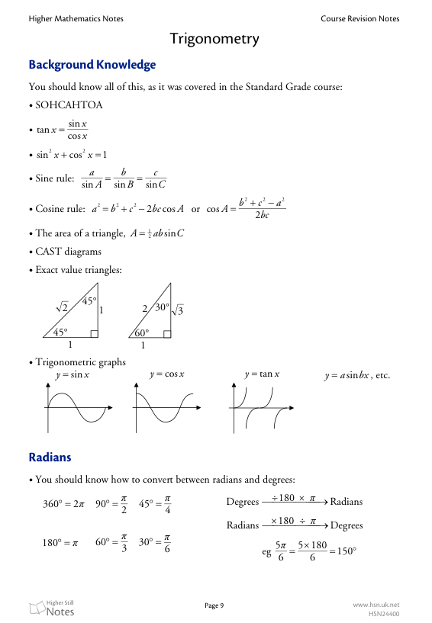

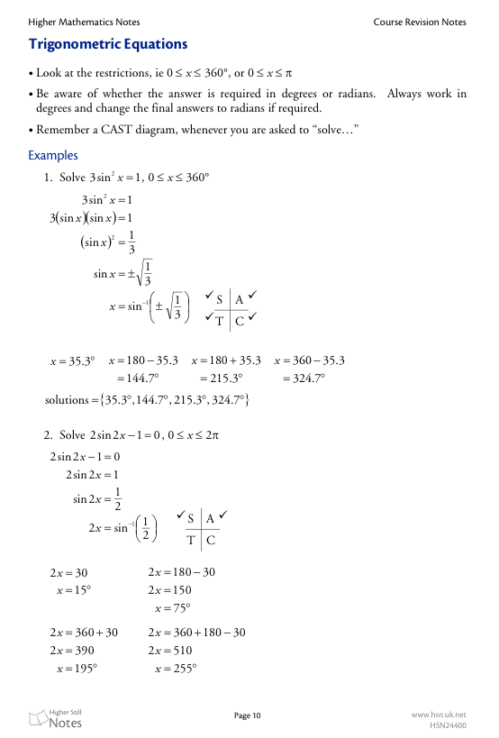

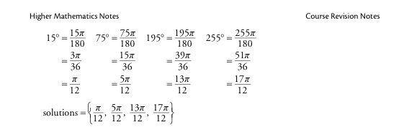

Trig. Equations

1. Solve each of the following equations :

(*a*) 

(*b*) 

(*c*) 

(*d*) 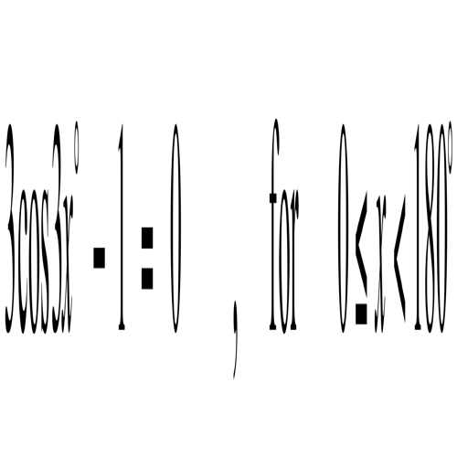

2. Solve each of the following equations for  :

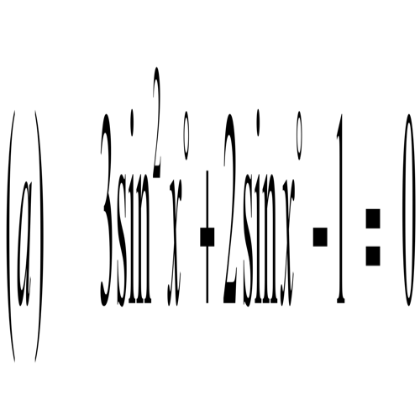 (*b*) 

(*c*) 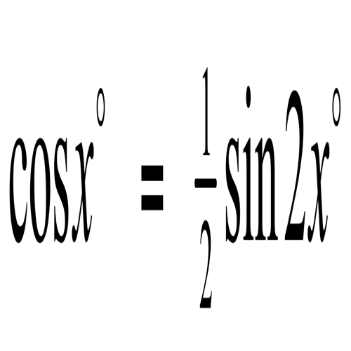 (*d*) 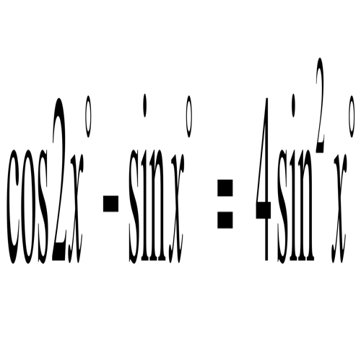

3. Solve the equation  .

4. Solve 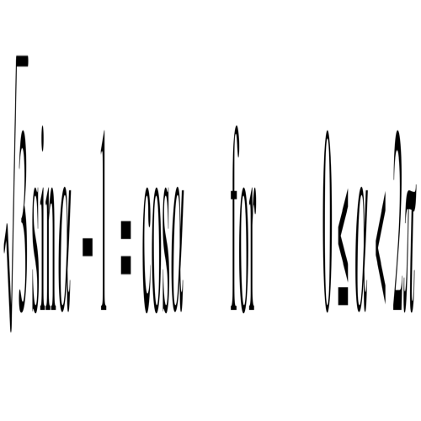 .

5. The solution of the equation ;  is

**A.** 44o and 224o

**B.** 44o and 104o

**C.** 14o and 134o

**D.** 224o and 316o

6. The exact value of  is

**A.** 

**B.** 

**C.** 

**D.** 

7. The solution set of the equation  for  is

**A.** 30o and 60o

**B.** 60o and 120o

**C.** 240o and 300o

**D.** 120o and 150o

8. The solution set of the equation ;  are

**A.** {200o, 260o}

**B.** {20o, 80o}

**C.** {170o, 290o}

**D.** {110o, 300o}

9. The solution set of the equation ;  is

**A.** {30o, 150o}

**B.** {60o, 120o}

**C.** {30o, 150o, 210o, 330o}

**D.** {60o, 120o, 240o, 330o}